**Lernunterstützungs-/Buddy-App M3**

Gruppe 3

11826583 - Merita Mehanovic

12028429 - Tobias Winter

12026025 - Viktoriia Timontieieva

12131411 - Masham Ali

**Contents**

**1. Prototype Description 2**

**2. Distribution of Work** **9**

# 1. Prototype Description

The StudyMate application prototype sets up a user-friendly platform for students to create accounts, login, and personalize their experience while easily accessing essential features like chat, calendar, matching algorithm, and friends list.

MainActivity:

Upon launching the app, users are greeted with a welcome screen (MainActivity). This screen contains:

* A welcome message.
* A logo image.
* Two primary buttons: "Login with Email" and "Create StudyMate account."
* A button to change the background theme, which cycles through predefined gradients.

CreateAccount Activity:

The CreateAccount activity enables users to register by providing necessary details. This screen includes:

* Username, password, email, and phone number.
* University selection from a dropdown list.
* Tags selection through a dialog.
* A special requests field.
* An option to upload a profile picture.
* Buttons to start matching and to go back to the previous screen.

LoginEmail Activity:

Additionally, a LoginEmail activity is included, featuring:

* Input fields for email and password.
* A login button to authenticate the user.

The SettingsActivity connects all other features like Calendar, Matching Algorithm, Chat, and Friends List. This screen includes:

* Buttons to navigate to the Chat, Calendar, Matching Algorithm, and Friends List screens.
* A button to change the background theme, just like in the MainActivity, lets users cycle through four gradient backgrounds to personalize their experience.

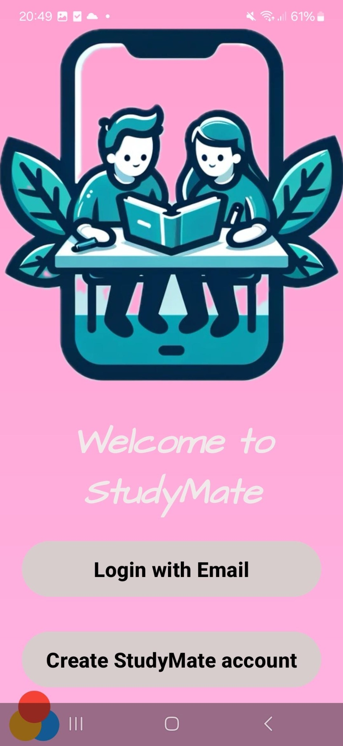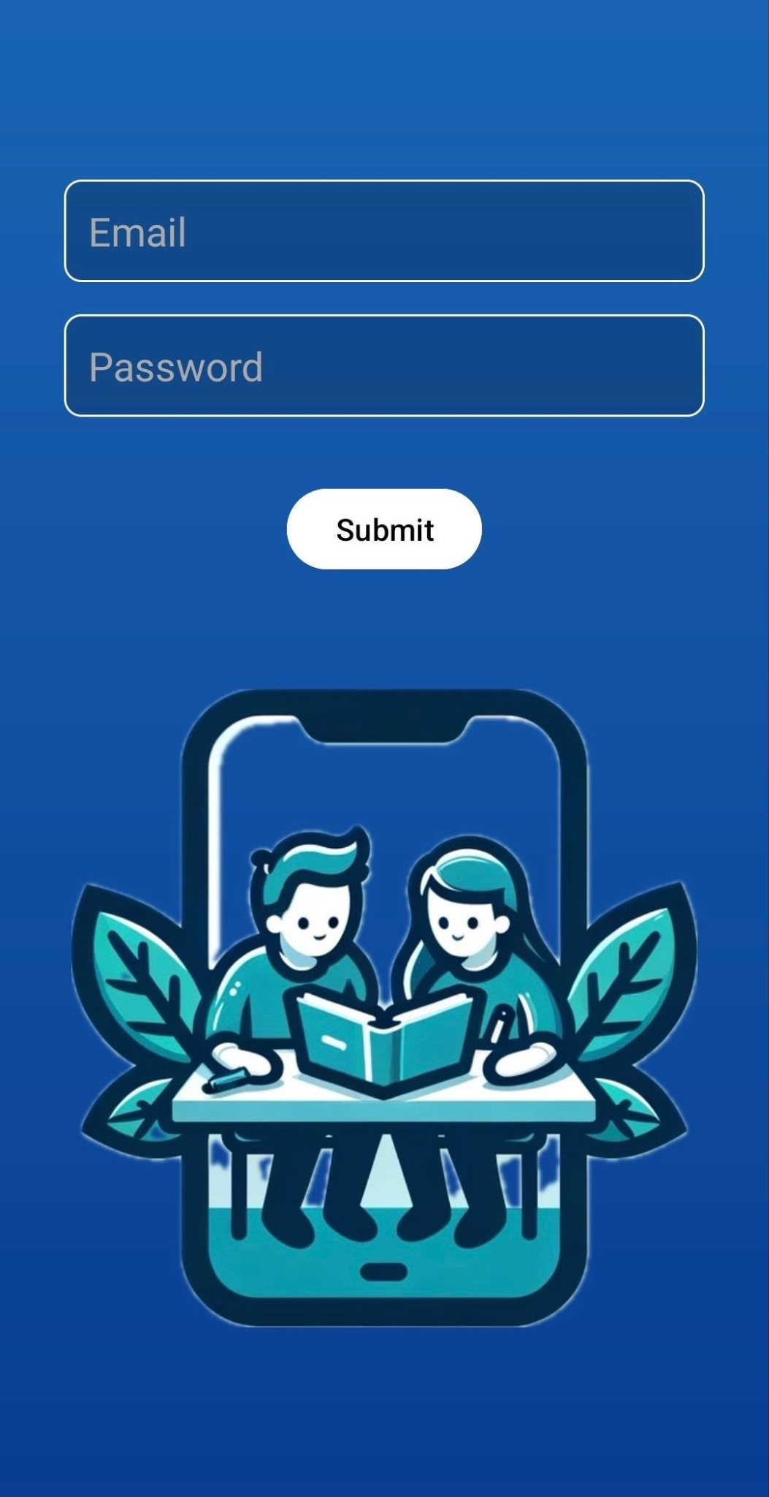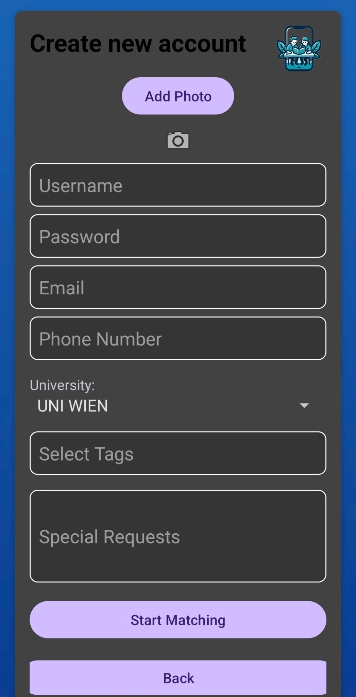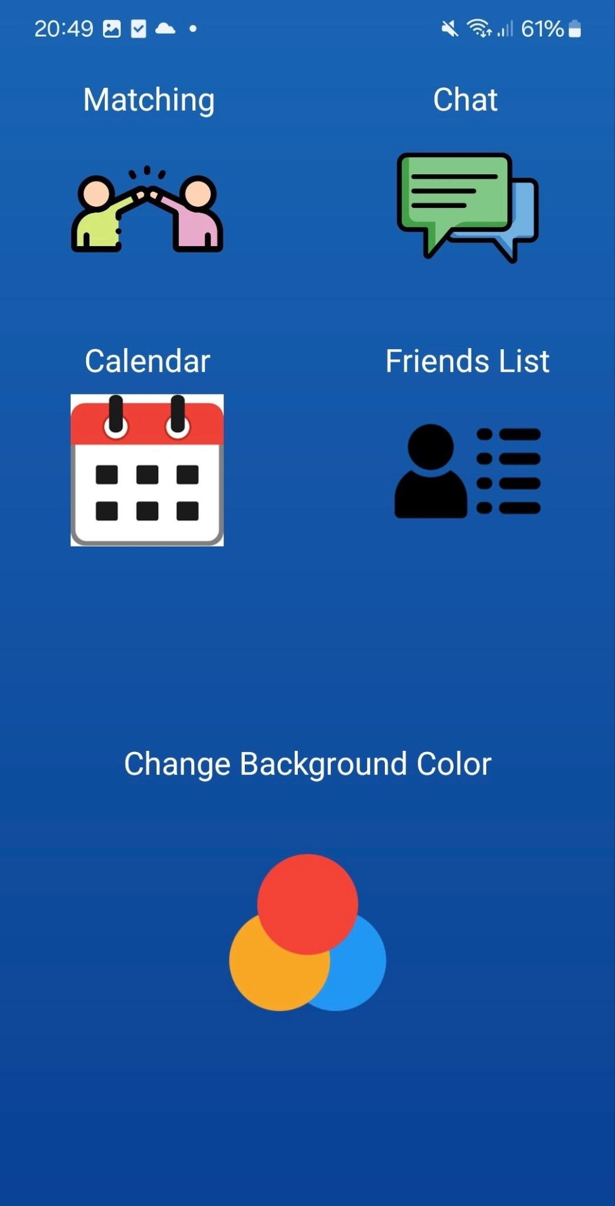

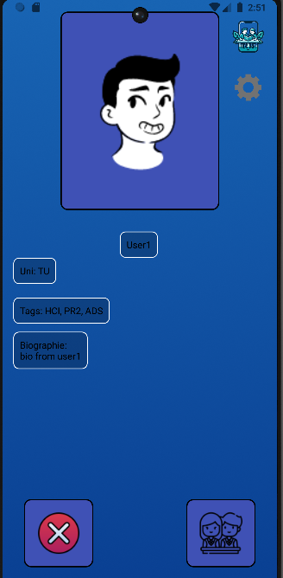

### Friends List

The Friends List is designed to provide users with an easy way to manage their list of friends. Upon opening this screen, users are presented with a vertically scrolling list of their friends that they matched with. Each friend is displayed with their profile picture, name, and three action icons for chat, delete, and info. This layout ensures that all relevant actions can be performed quickly and intuitively.

One of the main functionalities of this screen is the ability to chat with friends. By clicking the chat icon next to a friend's name, users are taken directly to the Chat screen, where they can engage in a conversation with that friend. The delete icon allows users to remove a friend from their list; upon clicking this icon, the friend is removed from the list, and the RecyclerView is updated to reflect this change. The info icon provides access to more detailed information about the friend, opening a profile screen where additional details can be viewed.

The screen also features a toolbar with a settings button, enabling users to navigate to the settings.

### Chat List

The Chat List provides an overview of recent chat conversations. This screen is designed to display a list of recent chats in a vertically scrolling format. Each chat item includes the friend's profile picture, name, last message, and timestamp, giving users a quick summary of their recent interactions.

Users can open a chat by clicking on any item in the list, which takes them to the Chat for that particular conversation. This seamless navigation ensures that users can quickly move between different chats.

### Chat

The Chat screen is the primary interface for direct messaging between users and their friends. This screen is designed to display the chat history in a vertically scrolling list, where messages are shown as either sent or received, with different layouts for each type to visually distinguish between them.

At the bottom of the screen, there is an EditText field for typing new messages, and a send button to send the message. This straightforward layout allows users to easily compose and send messages. Incoming messages are displayed in real-time, ensuring that the conversation remains up-to-date without requiring manual refreshes.

The Chat screen also features a toolbar with a chats button, allowing users to return to the Chat List.

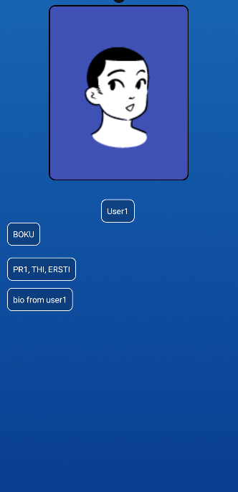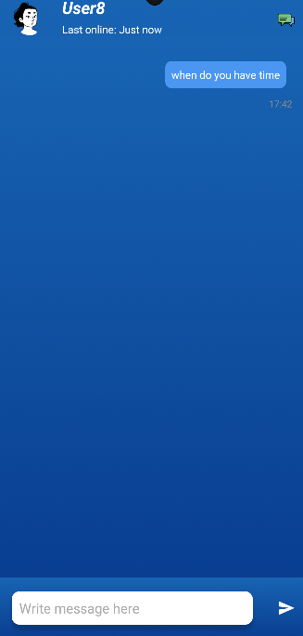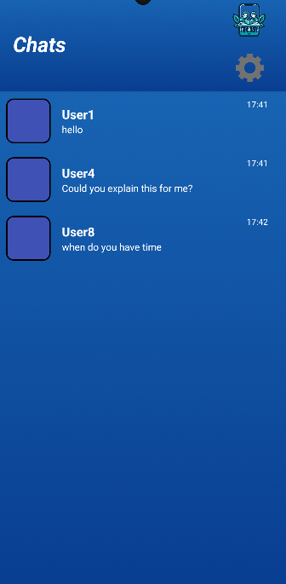

### Calendar

The calendar offers two main functions:

**Private Event Scheduling**: Users can easily set up their own events, like meetings or reminders, with customizable details and reminders.

**Collaborative Scheduling via Chat:** Users can share their available time slots with others through chat. For example, if you need to plan a meeting with a study-mate, you can send them your available times, and they can pick the slot that works best for them.

This feature takes the hassle out of scheduling by eliminating back-and-forth emails or messages.

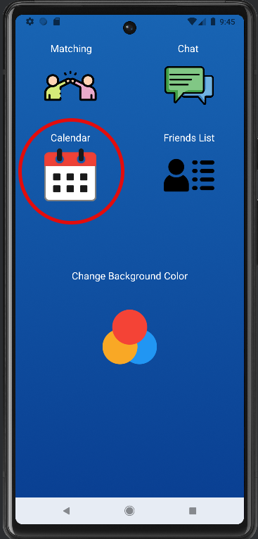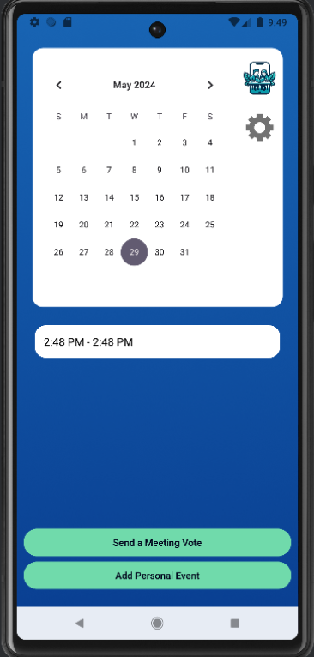

**Private Event Pop-up**

Here a user can enter an invent title, choose date and time.

Upon clicking the Create Event button a new event is created in the local device’s database the user is returned back to the main screen. The Event is then retrieved and shown on a main calendar screen.

Upon clicking the Go Back button the user is returned back to the main screen.

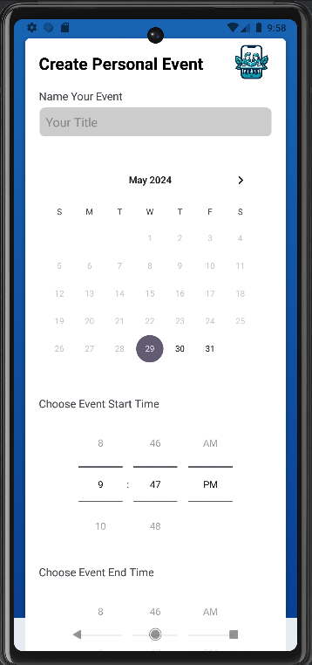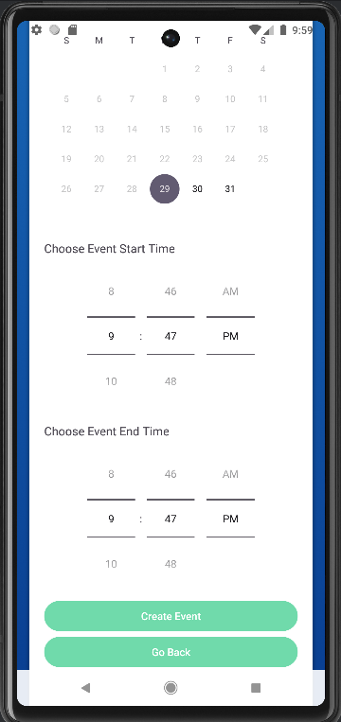

**Send a Meeting Vote Pop-up**

Here a user can enter an invent title, choose date and time slots. Each time slot is an one hour time slot.

Upon clicking the Add Timeslot button a new timeslot is added (timeslots are removable).

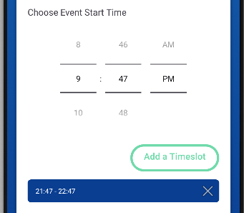

Upon clicking the Send Meeting Vote button the user is sent to Chat List, where they can choose a chat to send a vote.

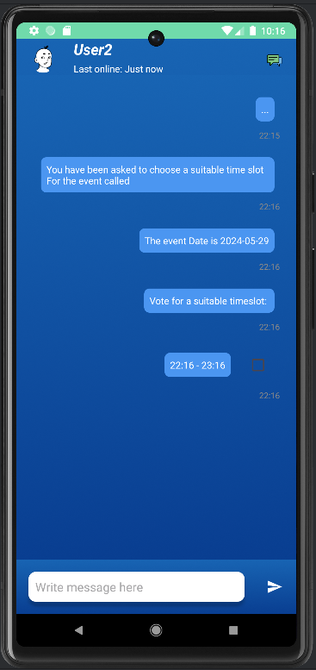

# 

# 2. Distribution of Work

Tobias Winter:

* UML
* Matching Algorithm

Masham Ali:

* Chat
* Friendlist
* Chatlist

Viktoriia Timontieieva:

* Calendar
* Scheduling
* Voting

Merita Mehonovic:

* Welcome page
* Settings (Menu)
* Color change
* Account creation